|  |  |  |
| --- | --- | --- |
| D:\Aptech - FPT\semester 2\eProject\documentation\LogoAptech.png | D:\Aptech - FPT\semester 2\eProject\documentation\LogoAptech.png | D:\Aptech - FPT\semester 2\eProject\documentation\LogoAptech.png |

Center Name: ACE-HCMC-2-FPT (VN.033).

Address: 590 Cach Mang Thang 8 Street, District 3, Ho Chi Minh City, Vietnam.



**LOAN PROCESSING SYSTEM**

**Design Document**

|  |  |  |  |
| --- | --- | --- | --- |
| **Faculty:** |  | **Ms. Dao Ngoc Anh** |  |
| **Batch No:** |  | **F2111306S0** |  |
| **Group No.:** |  | **2** |  |
| **Students:** |  | **Fullname** | **Roll No.** |
|  | 1. | Nguyen Vu Nhan | student741094 |
|  | 2. | Tu Khanh Liem | student740189 |
|  | 3. | Nguyen Minh Nhat | student740223 |
|  | 4. | Pham Anh Tuan | student740288 |

**Mar, 2014**

Contents

**REVIEW 1** 3

**I.** **Introduction** 4

**II.** **Exiting Scenario** 4

**III.** **Proposed Solution** 4

**IV.** **Function Of Application** 5

**V.** **The Roles of Application** 6

**VI.** **Function Diagram** 7

**1.** **Login process** 7

**2.** **Search Function** 7

**3.** **Change Password Function** 8

**4.** **Manager Function** 8

**5.** **Staff Function** 9

**6.** **Customer Function** 9

**VII.** **Hardware/Software Requirements** 10

**VIII.** **Tasksheet** 11

**REVIEW 2** 12

Architecture and Design of Project 13

**I.** **Data Flow Diagram** 14

**II.** **Database Design** 21

Database Relationship Diagram (DRD) 24

**III.** **Algorithms** 27

**IV.** **TaskSheet** 30

**REVIEW 3** 31

Login 32

MainFrame 33

ChangePassword 35

ManageBranch 36

ManageDepartment 37

ManageStaff 38

AppovedLoan 39

ManageCustomer 40

ManageLReq 42

MonthlyInstallment 44

ManageReport 46

Report 47

CustomerForm 49

LoanRequirementDetails 51

Help 52

Task sheet 53

# REVIEW 1

1. **Introduction**

“Quick Loan” is a company involved in providing loans to its customers. They have branches set up at different parts of the city. They cater to different types of loans like the vehicle loan, house loan, personal loan and loan to student higher studies.

Since the business is increasing day by day, Senior managers have decided to computerize the entire loan processing system and you have been given this task. The project has been named LPS (Loan Processing System).

1. **Exiting Scenario**

* Currently there are separate department for handling the different types of loans like for handling vehicle loans – Vehicle Finance Department, Housing Loans – Home Finance, personal loans – Personal Finance and for educational loan – Educational Finance.
* When any person applies for the loan, they have to fill the application form mentioning the personal and details of loan requirement. The Staff will help Customer input the information. Depending on the type of loan, the application is forwarded to the concerned department
* Further the details are verified by the respective department and the loan is sanctioned for the person. Also the department keeps track of the installments paid by the customer.

1. **Proposed Solution**

LPS will accept the details of the customer like his address, organization, gross salary etc. and then process the loan. The user will be able to choose the type of loan, loan amount, period and the branch from which the loan is asked. The system will then process the monthly installments based on the interest rates. The interest rates vary for different types of loans and the period. The system will also keep a track of the installments paid by the customer.

The customer details would be stored in the system and user be allowed to edit only the profile.

1. **Function Of Application**
2. Login/Logout: allow Customer, Senior Manager, Staffs login/logout into System. For each level of member, there will be the respective rights.
3. Server configuration: Senior Manager can configure Server for corresponding with each environment.
4. Change Password: allow Customer, Senior Manager, Staffs can change their Password.
5. Accept: allow Staff input Customer’s Information and details of loan requirement. The System will store Customer’s information and details of loan requirement.
6. Generate Account No: generate unique loan account no. for each new Customer.
7. Approved loans: Senior Manager will agree/disagree the loan requirement.
8. Process the loan: this should include the calculating the loan eligibility for the customer based on the details given.
9. Create Monthly Installment Table to customer base on interest rates.

|  |  |  |  |
| --- | --- | --- | --- |
| Sr. No | Type of loan | Period | Interest rate  (per Year) |
| 1 | Vehicle loan | 6 Months | 15.6% |
| 2 | 1 Year | 13 % |
| 3 | Personal loan | 6 Months | 20.4% |
| 4 | 1 Year | 18% |
| 5 | Home Loan | 1 Year | 10% |
| 6 | 2 Years | 8.4% |
| 7 | Educational | 1 Year | 5% |
| 8 | 2 Years | 4.8% |

1. Keep a track of the installment paid by customer.
2. Process the fine:

|  |  |  |
| --- | --- | --- |
| Sr. No | Criteria | Fine |
| 1 | 1< installment < 5000 | 2% |
| 2 | 5001< installment< 20,000 | 5% |
| 3 | 20,001< installment | 8% |

1. Generate report for Customer:

* All customer report: this will provide the details of customer as name, contact details, loan amount, date of disbursal of loan, monthly installment, no. of installments paid till date, balance to be paid and duration of the loan.
* Payment due report: This will provide the details of customers for whom the date of payment has already passed but the payment is not yet done.
* Fine report: This will provide the details of the fine collected for the month with details of customer.

1. Search: The user will be able to perform search based on the loan account no, amount of loan and duration of loan.
2. Help: help option which will make the user aware of the various functions of the system.
3. **The Roles of Application**
4. **All member:**

* Login.
* Change Password.
* Search.

1. **Manager:**

* Branch Management (View, Insert, Update).
* Department Management (View, Update).
* Staff Management (View, Insert, Update).
* Approved loans (Agree/Disagree).
* Lock Staff’s Account.

1. **Staff:**

* Create Account No.
* Customer Management (View, Insert, Delete).
* Register for loan.
* Create Monthly Installment Table to customer.
* Keep a track of the installment paid by customer.
* Create report, View Report.

1. **Customers:**

* View Customer’s Information, Monthly Installment Table, reports.
* View Approved status of the loan requirements.

1. **Function Diagram**
2. **Login process**

Login

Notice Fail Login

Manager

Staff

Customer

Check

Login

True

False

1. **Search Function**

Search

Notice Fail Look in

Detail of Customer (information/Amount of loan/Duration of loan)

Look in Database

True

False

Account No

Amount of loan

Duration of loan

1. **Change Password Function**

Change Password

Notice Fail Validation

Validation

True

False

Input Old/New/Confirm Password

Database

1. **Manager Function**

Manager

Branch

Department

Staff

Lock Account

Insert, Update, View

Database

Loan Requirement

Approved Loans

1. **Staff Function**

Staff

Customer

Database

Create Loan Requirement

Report

Monthly Installment

Insert, Update, View

Keep a track

Create

1. **Customer Function**

Customer

View

Database

Customer’s Detail

Status of loan Requirement

Monthly Installment

1. **Hardware/Software Requirements**
2. **Hardware**

* A minimum computer system that will help you access all the tools in the courses is a Pentium 4 or better
* 512 MB of RAM or better
* HDD 10G free space available or better

1. **Software**

* Operating system: Windows XP (or higher if possible)
* Netbeans 6.5.1 or higher
* JDK 1.5 or higher (1.6 recommend)
* SQL Server 2008 or higher
* JDBC Driver 4

1. **Tasksheet**

|  |  |  |  |  |  |  |
| --- | --- | --- | --- | --- | --- | --- |
| **Project Ref.No: 2** | | **Project Title:**  **Loan Processing System** | **Date of Preparation of Activity Plan** | | | |
| **Sr. No.** | **Task** | | **Actual Start Date** | **Actual Days** | **Team Member Names** | **Status** |
| 01 | Introduction | | Mar, 3, 2014 | 4 | All Members | Completed |
| 02 | Exiting Scenario | | All Members | Completed |
| 03 | Proposed Solution | | All Members | Completed |
| 04 | Function Of Application and The Roles of Application | | All Members | Completed |
| 05 | Function Diagram | | All Members | Completed |
| 06 | Hardware/Software Requirements | | All Members | Completed |
| 07 | Tasksheet | | All Members | Completed |

|  |  |  |
| --- | --- | --- |
|  | Prepare By: Group 2 | Approved By: Faculty |
| Date: Mar, 2014 | Team Leader  **Pham Anh Tuan** | **Dao Ngoc Anh** |

# REVIEW 2

## Architecture and Design of Project

Tier 1

Presentation

Tier 3

Data Access

Tier 2

Business Logic

Three-Tier Architecture of the Project

1. **Data Flow Diagram**

**Definition:** Data Flows Diagram (DFD) describes the information flow in the system. The next step of system analysis is to consider in detail the information necessary for the implementation for functions discussed above and the one necessary for the improvement of the functions. Modeling tool frequently used for this purpose is DFD. DFD will support 4 main activities:

* **Analysis:** DFD is used to determine requirement of users.
* **Design:** DFD is used to map out plan and illustrate solution to analysis and users while designing a new system.
* **Communication:** one of the strength of DFD is its simplicity and ease to understand to analysts and users;
* **Document:** DFD is used to provide special description of requirement and system design. DFD provide an overview of key functional components of the system but it does not provide any detail on these components. We have to use other tools like database dictionary, process specification to get an idea of which information will be exchanged and how.

**The main components of Context Diagram:**

**External**

**The process**: Show the common function of system.

**The external factors**: External factors can be a person, a group of persons or an organization that are sources of information for the systems and are where system products are transferred to.

**The data flow**: Describe the movement of information from one part of the system to another.

**The data store**: The Data Store is used to model a collection of data packets at rest. A store is represented graphically by two parallel lines. The name of a Data Store that identifies the store is the plural of the name of the packets that are carried by flows into and out of the Data Store.

Data Flow

External

Process

Data Store

**DFD level 0 – Context Diagram**

**Manager**

Manager Details

**Customer**

**Staff**

**Report**

**Monthly Installment**

**Loan Requirement**

**Fine**

Report Details

Fine Details

Monthly Installment Details

Loan Requirement Details

Staff Details

Customer Details

DFD – Login

**Manager, Staff, Customer**

Username, Password

**Staff**

Return Auth. Info

**Customer**

DFD – Logout

**Manager, Staff, Customer**

Username

**Staff**

Return Auth. Info

**Customer**

DFD – Manager

**Manager**

**Staff**

Validate/Get Information

Validate/Get Information

Validate/Get Information

Get Information

Reports/Command

Reports/Command

Reports/Command

Reports/Command

Validate/Get Information

Reports/Command

**Manager**

Validate/Get Information

Validate/Get Information

Get Information

Reports/Command

Reports/Command

Reports/Command

**Department**

**Manager**

Validate/Get Information

Validate/Get Information

Validate/Get Information

Get Information

Reports/Command

Reports/Command

Reports/Command

Reports/Command

**Branch**

**Manager**

Get Information

Update/Get Information

Reports/Command

**Loan Requirement**

Reports/Command

DFD – Staff

**Staff**

Validate/Get Information

Validate/Get Information

Validate/Get Information

Get Information

Reports/Command

Reports/Command

Reports/Command

Reports/Command

**Customer**

**Staff**

Validate/Get Information

Validate/Get Information

Get Information

Reports/Command

Reports/Command

Reports/Command

**Loan Requirement**

Reports/Command

Validate/Get Information

**Staff**

Validate/Get Information

Validate/Get Information

Validate/Get Information

Get Information

Reports/Command

Reports/Command

Reports/Command

Reports/Command

**Monthly Installment**

**Staff**

Validate/Get Information

Validate/Get Information

Get Information

Reports/Command

Reports/Command

Reports/Command

**Fine**

Reports/Command

Validate/Get Information

DFD – Customer

**Customer**

Get Information

Validate/Get Information

Get Information

Reports/Command

Reports/Command

Reports/Command

Reports/Command

**Monthly Installment**

**Loan Requirement**

**Customer**

**Fine**

Get Information

Get Information

Reports/Command

1. **Database Design**

Entity Relationship Diagram (ERD)

Department

Has

1

n

n

n

1

1

n

1

n

Staff

Create

Loan Requirement

Register

Customer

Has

Branch

Monthly Installment

Has

Has

Fine

1

1

Entity and Properties

* Branch

**Branch**

* Department

**Department**

* Staff

**Staff**

* Customer

**Customer**

* Loan Requirement

**Loan Requirement**

* Monthly Installment

**Monthly Installment**

* Fine

**Fine**

### Database Relationship Diagram (DRD)

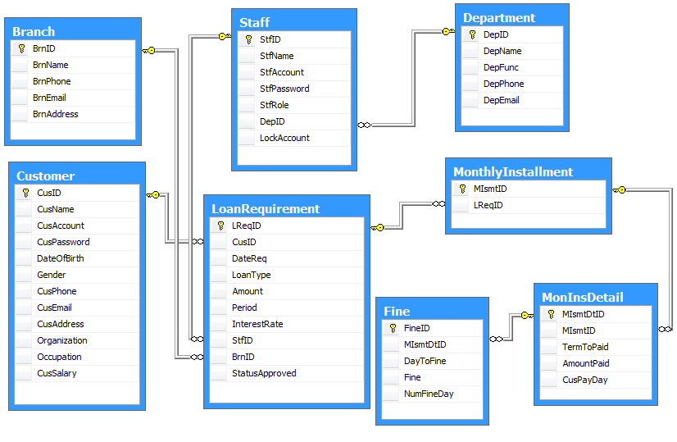

Database Structure

|  |  |  |  |  |  |  |
| --- | --- | --- | --- | --- | --- | --- |
| **Branch** | | | | | | |
| **Column Name** | **Data Type** | **Allow Null** | **Default Value** | **Key** | **Validation** | **Description** |
| BrnID | varchar(10) | No |  | Primary |  | ID of Branch |
| BrnName | varchar(50) | No |  |  | No duplication | Name of Branch |
| BrnPhone | varchar(20) | No |  |  |  | Phone of Branch |
| BrnEmail | varchar(100) |  |  |  |  | Email of Branch |
| BrnAddress | varchar(100) | No |  |  |  | Address of Branch |

|  |  |  |  |  |  |  |
| --- | --- | --- | --- | --- | --- | --- |
| **Department** | | | | | | |
| **Column Name** | **Data Type** | **Allow Null** | **Default Value** | **Key** | **Validation** | **Description** |
| DepID | varchar(10) | No |  | Primary |  | ID of Department |
| DepName | varchar(50) | No |  |  | No duplication | Name of Department |
| DepFunc | varchar(100) | No |  |  |  | Function of Department |
| DepPhone | varchar(20) | No |  |  |  | Phone of Department |
| DepEmail | varchar(100) |  |  |  |  | Email of Department |

|  |  |  |  |  |  |  |
| --- | --- | --- | --- | --- | --- | --- |
| **Staff** | | | | | | |
| **Column Name** | **Data Type** | **Allow Null** | **Default Value** | **Key** | **Validation** | **Description** |
| StfID | varchar(10) | No |  | Primary |  | ID of Staff |
| StfName | varchar(30) | No |  |  |  | Name of Staff |
| StfAccount | varchar(30) | No |  |  | No duplication | Account to Login |
| StfPassword | varchar(30) | No |  |  |  | Password to Login |
| StfRole | varchar(10) | No |  |  |  | Role to Permission |
| DepID | Referenced from Department Table | | | | |  |
| LockAccount | Bit | No | 0 |  |  | Locked person who don’t work for a long time. |

|  |  |  |  |  |  |  |
| --- | --- | --- | --- | --- | --- | --- |
| **Customer** | | | | | | |
| **Column Name** | **Data Type** | **Allow Null** | **Default Value** | **Key** | **Validation** | **Description** |
| CusID | int | No |  | Primary |  | ID of Customer |
| CusName | varchar(30) | No |  |  |  | Name of Customer |
| CusAccount | varchar(10) | No |  |  | No duplication | Account to Login |
| CusPassword | varchar(30) | No | 123 |  |  | Password to Login |
| DateOfBirth | datetime | No |  |  |  | Date of Birth of Customer |
| Gender | bit | No |  |  |  | Gender of Customer |
| CusPhone | varchar(20) | No |  |  |  | Phone of Customer |
| CusEmail | varchar(100) |  |  |  |  | Email of Customer |
| CusAddress | varchar(100) | No |  |  |  | Address of Customer |
| Organization | varchar(100) | No |  |  |  | Organization of Customer |
| Occupation | varchar(100) | No |  |  |  | Occupation of Customer |
| CusSalary | money | No |  |  |  | Salary of Customer |
| BrnID | Referenced from Branch Table | | | | |  |

|  |  |  |  |  |  |  |
| --- | --- | --- | --- | --- | --- | --- |
| **LoanRequirement** | | | | | | |
| **Column Name** | **Data Type** | **Allow Null** | **Default Value** | **Key** | **Validation** | **Description** |
| LReqID | int | No |  | Primary |  | ID of Loan Requirement |
| CusID | Referenced from Customer Table | | | | |  |
| DateReq | Datetime | No | Current Day |  |  | The day that Requirement was created |
| LoanType | varchar(100) | No |  |  |  | Type of Loan |
| Amount | money | No |  |  |  | Amount of Loan |
| Period | datetime | No |  |  |  | Duration of Loan |
| InterestRate | int | No |  |  |  | Rate of Loan Type |
| StfID | Referenced from Staff Table | | | | |  |
| BrnID | Referenced from Branch Table | | | | |  |
| StatusApproved | Varchar(20) | No | Pending |  |  | Status of Requirement |

|  |  |  |  |  |  |  |
| --- | --- | --- | --- | --- | --- | --- |
| **MonthlyInstallment** | | | | | | |
| **Column Name** | **Data Type** | **Allow Null** | **Default Value** | **Key** | **Validation** | **Description** |
| MIsmtID | varchar(10) | No |  | Primary |  | ID of Monthly Installment |
| LReqID | Referenced from LoanRequirement Table | | | | |  |
| DisbursalDate | Datetime | No | Current Day |  |  | The day that Customer given money and had monthly installment table |

|  |  |  |  |  |  |  |
| --- | --- | --- | --- | --- | --- | --- |
| **MonInsDetails** | | | | | | |
| **Column Name** | **Data Type** | **Allow Null** | **Default Value** | **Key** | **Validation** | **Description** |
| MIsmtDtID | int | No |  | Primary |  | ID of Monthly Installment Details |
| MIsmtID | Referenced from MonthlyInstallment Table | | | | |  |
| TermToPaid | datetime | No |  |  |  | The day that customer must pay installment |
| AmountPaid | money | No |  |  | Less than Amount | The number of money pay by month/quarter |
| CusPayDay | datetime | No | Current Date |  |  | Real day customer pay installment |

|  |  |  |  |  |  |  |
| --- | --- | --- | --- | --- | --- | --- |
| **Fine** | | | | | | |
| **Column Name** | **Data Type** | **Allow Null** | **Default Value** | **Key** | **Validation** | **Description** |
| FineID | int | No |  | Primary |  | ID of Fine |
| MIsmtDtID | Referenced from MonInsDetails Table | | | | |  |
| DayToFine | datetime | No | Current Day |  |  | The day export Fine Report |
| NumFineDay | int |  |  |  |  | Number of Day After export Fine Report |
| Fine | money | No |  |  |  | Fine |

1. **Algorithms**

* Approved Loan Requirement

Begin

Amount, Period, Interest Rate

(CusSalary * 2) >= X

Loan Requirement was approved

Loan Requirement was Disapproved

End

Store in database

True

False

* Monthly Installment

Begin

Amount, Period, Interest Rate

Monthly Installment

End

Store in database

* Fine

Begin

Monthly Installement, Fine Rate

End

Store in database

Installment Paid date greater pre-decided date

1. **TaskSheet**

|  |  |  |  |  |  |  |
| --- | --- | --- | --- | --- | --- | --- |
| **Project Ref.No: 2** | | **Project Title:**  **Loan Processing System** | **Date of Preparation of Activity Plan** | | | |
| **Sr. No.** | **Task** | | **Actual Start Date** | **Actual Days** | **Team Member Names** | **Status** |
| 01 | Data Flow Diagram | | Mar, 7, 2014 | 5 | All Members | Completed |
| 02 | Entity Relationship Diagram (ERD) | | All Members | Completed |
| 03 | Entity and Properties | | All Members | Completed |
| 04 | Database Relationship Diagram (DRD) | | All Members | Completed |
| 05 | Database Structure | | All Members | Completed |
| 06 | Algorithms | | All Members | Completed |
| 07 | Tasksheet | | All Members | Completed |

|  |  |  |
| --- | --- | --- |
|  | Prepare By: Group 2 | Approved By: Faculty |
| Date: Mar, 2014 | Team Leader  **Pham Anh Tuan** | **Dao Ngoc Anh** |

# REVIEW 3

## Login

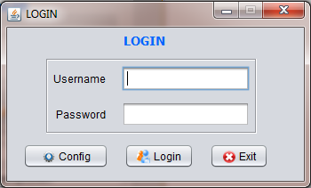 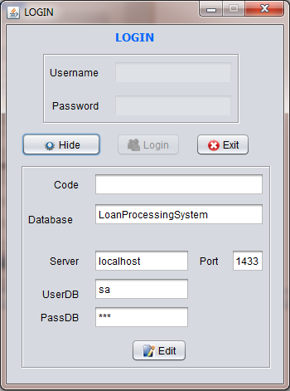

**13**

**12**

**11**

**10**

**9**

**8**

**7**

**6**

**5**

**4**

**3**

**2**

**1**

|  |  |  |  |  |
| --- | --- | --- | --- | --- |
| **No** | **Item** | **Type** | **Validation** | **Description** |
| 1 | Username | Text Field | Not blank | User’s Account |
| 2 | Password | Text Field | Not blank | User’s Password |
| 3 | Config | Button |  | Show the Server Config, the part of Login will not be Enabled. |
| 4 | Login | Button |  | Check Account and Password. If correct, login form will be closed, Main Form will be opened. |
| 5 | Exit | Button |  | Exit program |
| 6 | Hide | Button |  | Hide the Server Config, the part of Login will Enabled. |
| 7 | Code | Password Field | Not blank | The code that prevent Staff or Customer edit Server Config. Only Manager known that code.  The code is 123456. |
| 8 | Database | Text Field | Not blank | Database name: LoanProcessingSystem |
| 9 | Server Name | Text Field | Not blank | Server name: localhost |
| 10 | Port | Text Field | Not blank, a number | Port: 1433 |
| 11 | Username | Text Field | Not blank | Username login database: sa |
| 12 | Password | Text Field | Not blank | Password login database: 123 |
| 13 | Edit | Button |  | When edit button was pressed, Manager can edit server config. Then edit button changed to save button for saving some change. |

## MainFrame

**7**

**4**

**3**

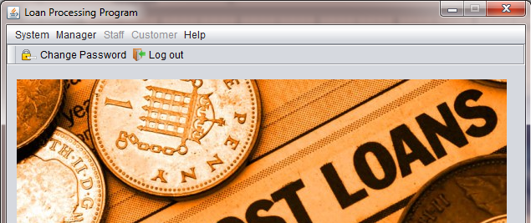

**6**

**5**

**1**

**2**

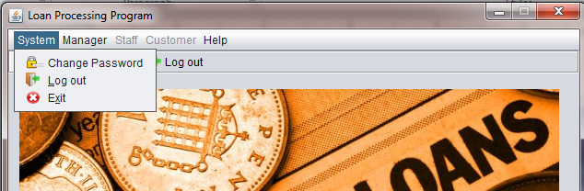 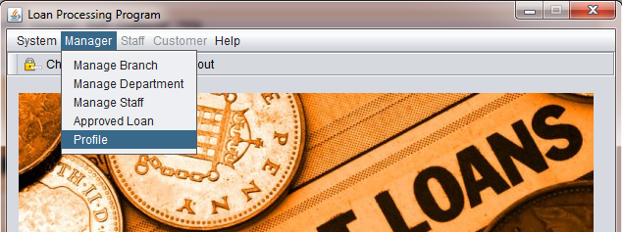

**15**

**14**

**13**

**12**

**11**

**10**

**9**

**8**

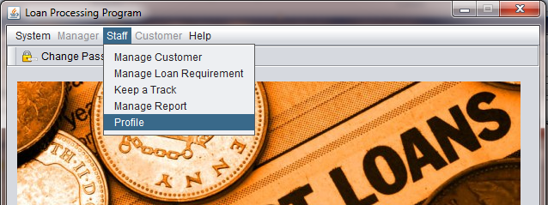 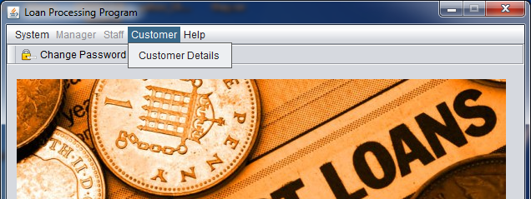

**21**

**20**

**19**

**18**

**17**

**16**

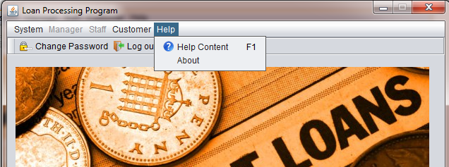

**22**

**23**

|  |  |  |  |  |
| --- | --- | --- | --- | --- |
| **No** | **Item** | **Type** | **Validation** | **Description** |
| 1 | Change Password | Button |  | Open Change Password Form |
| 2 | Log out | Button |  | Close Main Form, Open Login Form. |
| 3 | System | Menu |  | System Menu |
| 4 | Manager | Menu |  | Manager Menu (only Manager can view) |
| 5 | Staff | Menu |  | Staff Menu (only Staff can view) |
| 6 | Customer | Menu |  | Customer Menu (only Customer can view) |
| 7 | Help | Menu |  | Help Menu |
| 8 | Change Password | Menu Item |  | Open Change Password Form |
| 9 | Log out | Menu Item |  | Close Main Form, Open Login Form. |
| 10 | Exit | Menu Item |  | Exit Program |
| 11 | Manage Branch | Menu Item |  | Open Manage Branch Form |
| 12 | Manage Department | Menu Item |  | Open Manage Department Form |
| 13 | Manage Staff | Menu Item |  | Open Manage Staff Form |
| 14 | Approved Loan | Menu Item |  | Open Approved Loan Form |
| 15 | Profile | Menu Item |  | Open Profile Manager Form |
| 16 | Manage Customer | Menu Item |  | Open Manage Customer Form |
| 17 | Manage Loan Requirement | Menu Item |  | Open Manage Loan Requirement Form |
| 18 | Keep a Track | Menu Item |  | Open Monthly Installment Form |
| 19 | Manage Report | Menu Item |  | Open Manage Report Form |
| 20 | Profile | Menu Item |  | Open Profile Staff Form |
| 21 | Customer Details | Menu Item |  | Open Customer Form |
| 22 | Help Content | Menu Item |  | Open Help Form |
| 23 | About | Menu Item |  | Open About Form |

## ChangePassword

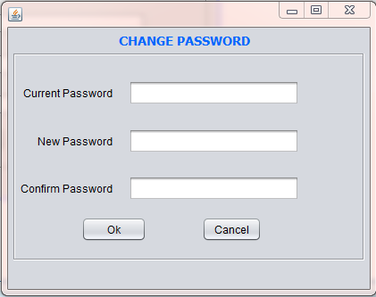

**4**

**5**

**3**

**2**

**1**

|  |  |  |  |  |
| --- | --- | --- | --- | --- |
| **No** | **Item** | **Type** | **Validation** | **Description** |
| 1 | Current Password | Password Field | Not blank, max length: 30 | Input User’s current password |
| 2 | New Password | Password Field | Not blank, max length: 30 | Input new password |
| 3 | Confirm Password | Password Field | Not blank, max length: 30. Confirm Password must same new password | Input confirm password |
| 4 | Ok | Button |  | Change Password, close Form. |
| 5 | Cancel | Button |  | Close Form, don’t change password |

## ManageBranch

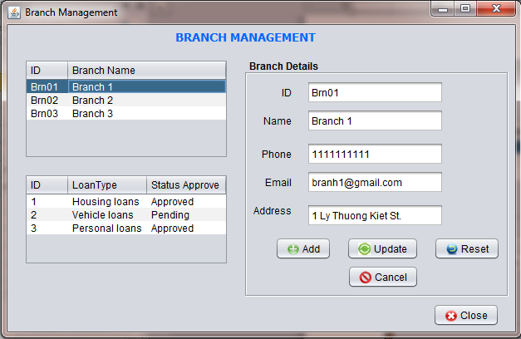

**12**

**11**

**10**

**9**

**8**

**7**

**6**

**5**

**3**

**4**

**1**

**2**

|  |  |  |  |  |
| --- | --- | --- | --- | --- |
| **No** | **Item** | **Type** | **Validation** | **Description** |
| 1 | Branch Table | Table |  | Show all Branches of LPS System |
| 2 | Loan Requirement Table | Table |  | Show all Loan Requiments of each Branch. When double click a row, program close this form and open Approved Loan Form. |
| 3 | ID | Text Field | Not blank | Branch ID |
| 4 | Name | Text Field | Not blank | Branch Name |
| 5 | Phone | Text Field | Not blank, be a number has 9 digit | Branch Phone |
| 6 | Email | Text Field |  | Branch Email |
| 7 | Address | Text Field | Not blank | Branch Address |
| 8 | Add | Button |  | Add new Branch. When Add button was pressed, it will change Save button for saving change. |
| 9 | Update | Button |  | Update Branch’s information. When Update button was pressed, it will change Save button for saving change. |
| 10 | Reset | Button |  | Reset form |
| 11 | Cancel | Button |  | Cancel Adding or Updating. |
| 12 | Close | Button |  | Close this form. |

## ManageDepartment

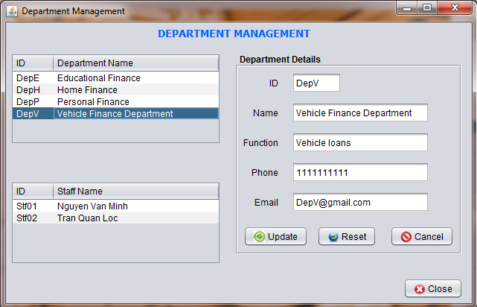

**8**

**9**

**10**

**3**

**11**

**4**

**5**

**6**

**7**

**2**

**1**

|  |  |  |  |  |
| --- | --- | --- | --- | --- |
| **No** | **Item** | **Type** | **Validation** | **Description** |
| 1 | Department Table | Table |  | Show All Departments of LPS System |
| 2 | Staff Table | Table |  | Show all Staffs (not Manager) of each Department. When double click a row of this Table, program will close this form and Open Manage Staff Form. |
| 3 | ID | Text Field | Not Blank | Department ID |
| 4 | Name | Text Field | Not Blank | Department Name |
| 5 | Function | Text Field | Not Blank | Department Function |
| 6 | Phone | Text Field | Not Blank | Department Phone |
| 7 | Email | Text Field |  | Department Email |
| 8 | Update | Button |  | Update Department’s information. When Update button was pressed, it will change Save button for saving change. |
| 9 | Reset | Button |  | Reset form |
| 10 | Cancel | Button |  | Cancel Adding or Updating. |
| 11 | Close | Button |  | Close this form. |

## ManageStaff

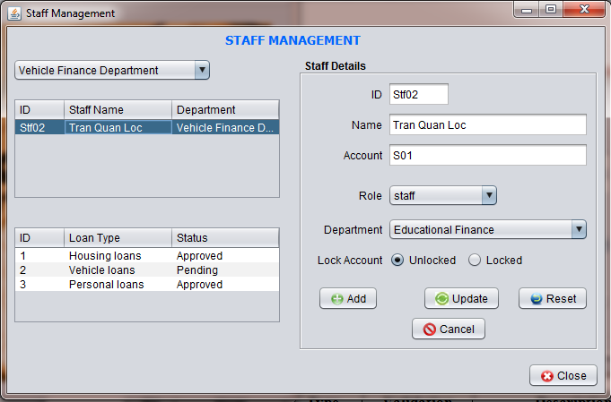

**15**

**14**

**11**

**12**

**13**

**9**

**10**

**8**

**7**

**6**

**5**

**4**

**3**

**2**

**1**

|  |  |  |  |  |
| --- | --- | --- | --- | --- |
| **No** | **Item** | **Type** | **Validation** | **Description** |
| 1 | Department | ComboBox |  | Select Departments Name |
| 2 | Staff Table | Table |  | Show all Staffs (not Manager) of each Department. |
| 3 | Loan Requirement Table | Table |  | Show all Loan Requirement of each Customer. When double click a row of this Table, program will close this form and Open Approved Loan Form. |
| 4 | ID | Text Field | Not Blank | Staff ID |
| 5 | Name | Text Field | Not Blank | Staff Name |
| 6 | Account | Text Field | Not Blank | Staff Account. |
| 7 | Role | ComboBox |  | Select Staff Role |
| 8 | Department | ComboBox |  | Select Department name |
| 9 | Unlocked | Radio Button |  | Choose Unlocked Staff Account |
| 10 | Locked | Radio Button |  | Choose locked Staff Account |
| 11 | Add | Button |  | Add new Staff. When Add button was pressed, it will change Save button for saving change. |
| 12 | Update | Button |  | Update Staff’s information. When Update button was pressed, it will change Save button for saving change. |
| 13 | Reset | Button |  | Reset form |
| 14 | Cancel | Button |  | Cancel Adding or Updating. |
| 15 | Close | Button |  | Close this form. |

*\* note: Staff mean not include Manager. Only person has role Staff.*

## AppovedLoan

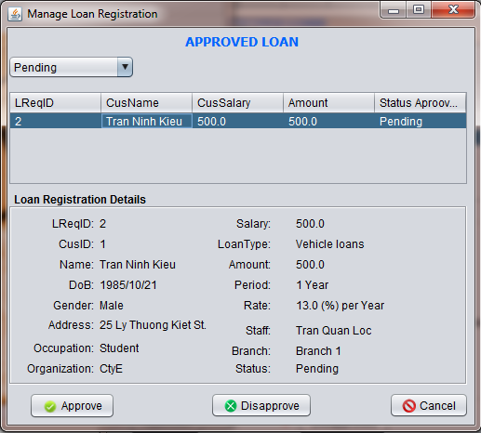

**4**

**5**

**6**

**1**

**2**

**3**

|  |  |  |  |  |
| --- | --- | --- | --- | --- |
| **No** | **Item** | **Type** | **Validation** | **Description** |
| 1 | Status | ComboBox |  | Select Status of Loan Requirement |
| 2 | Loan Requirement Table | Table |  | Show Loan Requirement based on Status selected |
| 3 | Loan Registratrion Details | Panel |  | Show Customer Details and Loan Requirement Details that Manage can Approved or not Approved. |
| 4 | Approved | Button |  | Approved this Requirement. |
| 5 | Disapproved | Button |  | Not Approved this Requirement. |
| 6 | Cancel | Button |  | Close this form. |

## ManageCustomer

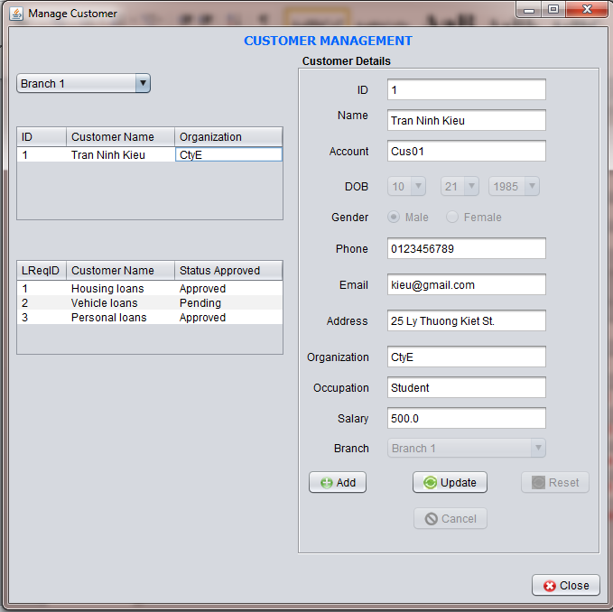

**1**

**21**

**17**

**20**

**18**

**19**

**16**

**14**

**15**

**13**

**12**

**11**

**10**

**7**

**9**

**8**

**6**

**5**

**4**

**3**

**2**

|  |  |  |  |  |
| --- | --- | --- | --- | --- |
| **No** | **Item** | **Type** | **Validation** | **Description** |
| 1 | Branch | ComboBox |  | Select BranchName |
| 2 | Customer Table | Table |  | Show all Customer of each Branch. |
| 3 | Loan Requirement Table | Table |  | Show all Loan Requirement of each Customer. When double click a row of this Table, program will close this form and Open ManageLReq Form. |
| 4 | ID | Text Field |  | Customer ID. Auto generated |
| 5 | Name | Text Field | Not blank | Customer Name |
| 6 | Account | Text Field |  | Customer Account. Auto generated |
| 7 | DOB | ComboBoxes |  | Select Customer Date of Birth |
| 8 | Male | Radio Button |  | gender |
| 9 | Female | Radio Button |  | gender |
| 10 | Phone | Text Field | Not blank, be a number has 9 digit | Customer Phone |
| 11 | Email | Text Field | Not blank | Customer Email |
| 12 | Address | Text Field | Not blank | Customer Address |
| 13 | Organization | Text Field | Not blank | Customer Organization |
| 14 | Occupation | Text Field | Not blank | Customer Occupation |
| 15 | Salary | Text Field | Not blank, be a number greater than 0 | Customer Salary |
| 16 | Branch | ComboBox |  | Branch that Customer registration |
| 17 | Add | Button |  | Add new Customer. When Add button was pressed, it will change Save button for saving change. |
| 18 | Update | Button |  | Update Customer’s information. When Update button was pressed, it will change Save button for saving change. |
| 19 | Reset | Button |  | Reset form |
| 20 | Cancel | Button |  | Cancel Adding or Updating. |
| 21 | Close | Button |  | Close this form. |

## ManageLReq

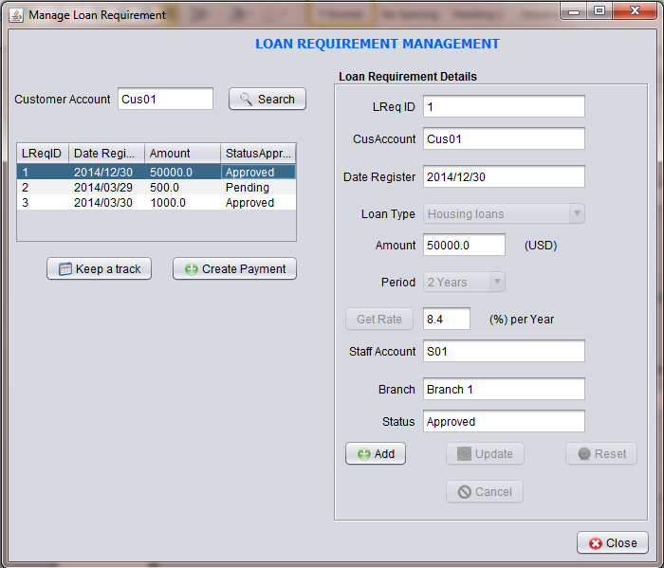

**21**

**20**

**17**

**18**

**19**

**16**

**15**

**14**

**13**

**11**

**12**

**10**

**9**

**8**

**7**

**6**

**4**

**5**

**2**

**1**

**3**

|  |  |  |  |  |
| --- | --- | --- | --- | --- |
| **No** | **Item** | **Type** | **Validation** | **Description** |
| 1 | Customer Account | Text Field |  | Customer Account |
| 2 | Search | Button |  | Show all Loan Requirement of Customer Account was given. |
| 3 | Loan Requirement Table | Table |  | Show all Loan Requirement of each Customer. When double click a row of this Table, program will close this form and Open Monthly Installment Form. |
| 4 | Keep a track | Button |  | Keep a track of Loan Requirement was selected. |
| 5 | Create Payment | Button |  | If Loan Requirement that was selected was approved and it didn’t have any Monthly installment, the program will create Monthly installment. |
| 6 | ID | Text Field |  | Loan Requirement ID. This ID will be generated when Add a new Loan Requirement. |
| 7 | Customer Account | Text Field | Not Blank | Customer Account |
| 8 | Date Registration | Text Field |  | Date of Registration. This Date will get current day when Add a new Loan Requirement. |
| 9 | Loan Type | ComboBox |  | Select Type of Loan |
| 10 | Amount | Text Field | Not blank, be a number greater than 100 | The money customer want to loan |
| 11 | Period | ComboBox |  | The duration of loan |
| 12 | GetRate | Button |  | Calculate Rate based on Loan Type and Period |
| 13 | Rate | Text Field |  | This Rate will be generated when click GetRate button. |
| 14 | Staff Account | Text Field |  | Staff Account that register for Customer. |
| 15 | Branch | ComboBox |  | The Branch where customer register. Auto generated |
| 16 | Status | Text Field |  | This status will be ‘Pending’ when Add a new Loan Requirement |
| 17 | Add | Button |  | Add new Loan Requirement. When Add button was pressed, it will change Save button for saving change. |
| 18 | Update | Button |  | Update Loan Requirement’s information. When Update button was pressed, it will change Save button for saving change. |
| 19 | Reset | Button |  | Reset form |
| 20 | Cancel | Button |  | Cancel Adding or Updating. |
| 21 | Close | Button |  | Close this form. |

## MonthlyInstallment

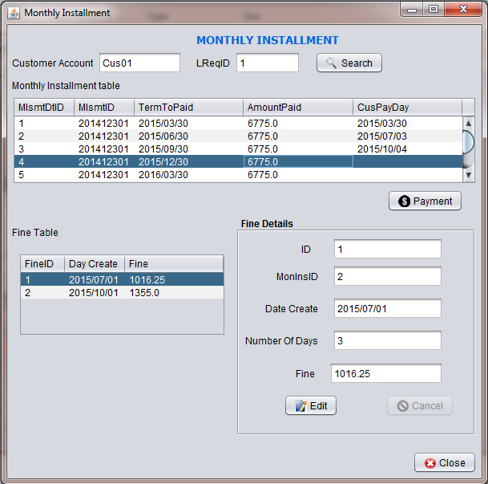

**6**

**13**

**14**

**12**

**4**

**5**

**11**

**10**

**9**

**8**

**7**

**3**

**2**

**1**

|  |  |  |  |  |
| --- | --- | --- | --- | --- |
| **No** | **Item** | **Type** | **Validation** | **Description** |
| 1 | Customer Account | Text Field | Not Blank | Customer Account |
| 2 | Loan Requirement ID | Text Field | Not blank | Loan Requirement ID |
| 3 | Search | Button |  | Searching base on Account and Loan Requirement ID. Program will show all Monthly Installment Details of each Loan Requirement. |
| 4 | Monthly Installment Table | Text Field |  | Show all Monthly Installment Details of each Loan Requirement. Click a row of this table, the details of Fine will show if possible. |
| 5 | Update | Button |  | Update Monthly Installment Details information. When Update button was pressed, it will change Save button for saving change. |
| 6 | Fine Table | Table |  | Show all Fine of each Monthly Installment. |
| 7 | ID | Text Field |  | Fine ID. Auto generated |
| 8 | MonInsID | Text Field | Not blank | Monthly Installment Details ID. |
| 9 | Date Create | Text Field |  | The day that create fine. This day will get the current day. |
| 10 | Number of Days | Text Field | Not blank | The number of days from create fine to customer pay fine money. |
| 11 | Fine | Text Field |  | The money of Fine. Auto generated. |
| 12 | Edit | Button |  | Update Update’s information. When Update button was pressed, it will change Save button for saving change. |
| 13 | Cancel | Button |  | Cancel Adding or Updating. |
| 14 | Close | Button |  | Close this form. |

## ManageReport

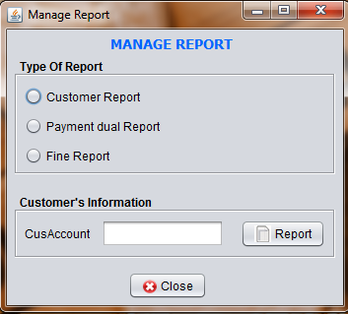

**5**

**6**

**2**

**3**

**4**

**1**

|  |  |  |  |  |
| --- | --- | --- | --- | --- |
| **No** | **Item** | **Type** | **Validation** | **Description** |
| 1 | Customer Report | Radio Button |  | Select Customer report |
| 2 | Payment Report | Radio Button |  | Select Payment Report |
| 3 | Fine Report | Radio Button |  | Select Fine Report |
| 4 | Account | Text Field | Not blank | Customer Account |
| 5 | Report | Button |  | Open Report Form corresponding with each selection above |
| 6 | Close | Button |  | Close this Form |

## Report

**1**

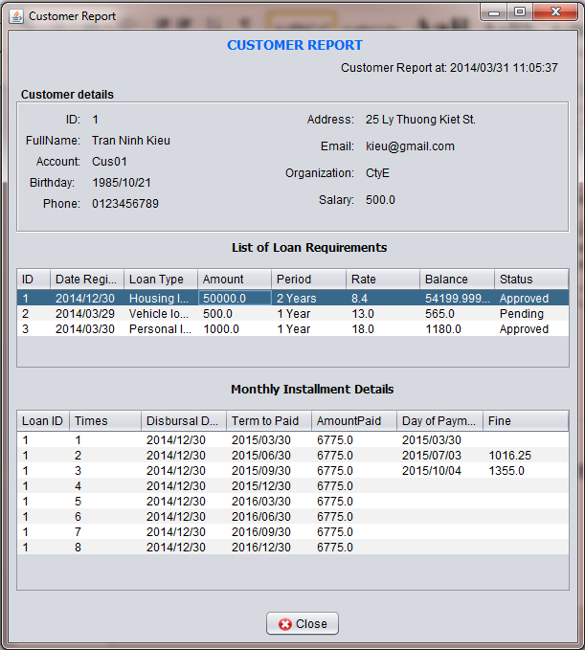

**6**

**5**

**4**

**3**

**2**

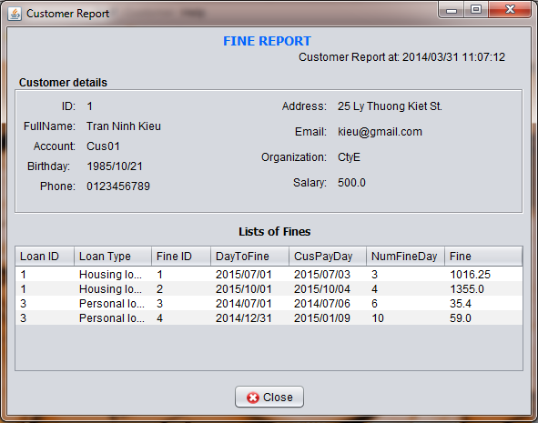

**11**

**9**

**10**

**7**

**8**

|  |  |  |  |  |
| --- | --- | --- | --- | --- |
| **No** | **Item** | **Type** | **Validation** | **Description** |
| 1 | Customer Report | JFrame |  | Customer Report |
| 2 | Current Date and Time | JLabel |  | Show current Date and Time |
| 3 | Customer Details | Jpanel and JLabels |  | Show Customer details |
| 4 | List Loan Requirement | JTable |  | Show All Loan Requirement of Customer above |
| 5 | Monthly Installment Details | JTable |  | Show Monthly Installment Details of each Loan Requirement. |
| 6 | Close | JButton |  | Close this form |
| 7 | Fine Report | JFrame |  | Fine Report |
| 8 | Current Date and Time | JLabel |  | Show current Date and Time |
| 9 | Customer Details | Jpanel and JLabels |  | Show Customer details |
| 10 | Fine Table | JTable |  | Show all Fine of Customer above |
| 11 | Close | JButton |  | Close this form |

## CustomerForm

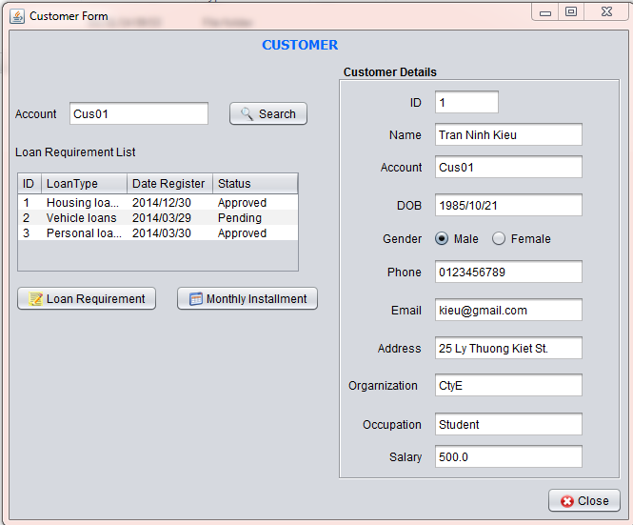

**10**

**17**

**16**

**15**

**14**

**13**

**12**

**11**

**9**

**8**

**7**

**6**

**4**

**5**

**3**

**2**

**1**

|  |  |  |  |  |
| --- | --- | --- | --- | --- |
| **No** | **Item** | **Type** | **Validation** | **Description** |
| 1 | Customer Account | Text Field | Not blank | Customer Account |
| 2 | Search | Button |  | Searching base on Account Program will show all Loan Requirement of each Account. |
| 3 | Loan Requirement Table | Table |  | Show all Loan Requirement Details of each Customer Account. |
| 4 | Loan Requirement | Button |  | Open Loan Requirement Details Form when select a row in Loan Requirement table. |
| 5 | Monthly Installment | Button |  | Open Monthly Installment Form when select a row in Loan Requirement table. |
| 6 | ID | Text Field |  | Customer ID |
| 7 | Name | Text Field |  | Customer Name |
| 8 | Account | Text Field |  | Customer Account |
| 9 | DOB | Text Field |  | Date of Birth |
| 10 | Gender | Radio Button |  | Customer gender |
| 11 | Phone | Text Field |  | Customer Phone |
| 12 | Email | Text Field |  | Customer Email |
| 13 | Address | Text Field |  | Customer Address |
| 14 | Organization | Text Field |  | Customer Organization |
| 15 | Occupation | Text Field |  | Customer Occupation |
| 16 | Salary | Text Field |  | Customer Salary |
| 17 | Close | Button |  | Close this form. |

## LoanRequirementDetails

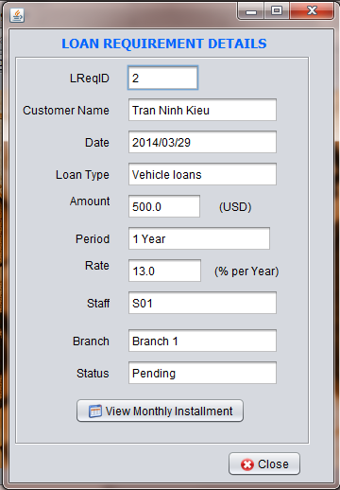

**12**

**11**

**4**

**3**

**2**

**10**

**9**

**8**

**7**

**6**

**5**

**1**

|  |  |  |  |  |
| --- | --- | --- | --- | --- |
| **No** | **Item** | **Type** | **Validation** | **Description** |
| 1 | ID | Text Field |  | Loan Requirement ID |
| 2 | Customer Name | Text Field |  | Customer Name |
| 3 | Date Register | Text Field |  | The day that register Loan |
| 4 | Loan Type | ComboBox |  | Type of Loan |
| 5 | Amount | Text Field |  | The money of loan |
| 6 | Period | ComboBox |  | Duration of Loan |
| 7 | Rate | Text Field |  | Rate based on Loan Type and Period |
| 8 | Staff | Text Field |  | The person who register for Customer |
| 9 | Branch | Text Field |  | The place that customer register Loan |
| 10 | Status | Text Field |  | Status of Loan |
| 11 | Monthly Installment | Button |  | Open Monthly Installment Form |
| 12 | Close | Button |  | Close this form. |

## Help

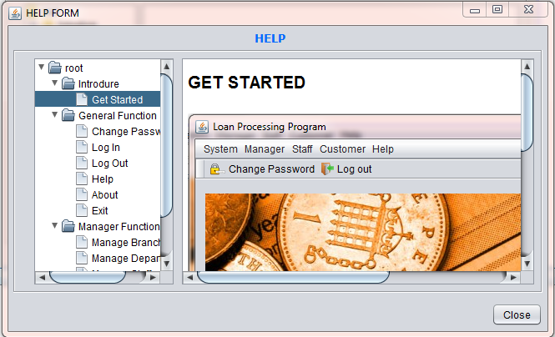

**3**

**2**

**1**

|  |  |  |  |  |
| --- | --- | --- | --- | --- |
| **No** | **Item** | **Type** | **Validation** | **Description** |
| 1 | Function | Jtree |  | Select function of program |
| 2 | Function details | EditorPane |  | Details of each function. |
| 3 | Close | Button |  | Close this form. |

## Task sheet

|  |  |  |  |  |  |  |
| --- | --- | --- | --- | --- | --- | --- |
| **Project Ref.No: 2** | | **Project Title:**  **Loan Processing System** | **Date of Preparation of Activity Plan** | | | |
| **Sr. No.** | **Task** | | **Actual Start Date** | **Actual Days** | **Team Member Names** | **Status** |
| 01 | Login, Main Frame | | Mar, 13, 2014 | 9 | Nguyen Minh Nhat | Completed |
| 02 | Change Password, Help | | Completed |
| 03 | Manage Branch, Manage Department | | Nguyen Vu Nhan | Completed |
| 04 | Manage Staff, Approved Loan | | Completed |
| 05 | Manage Customer, Manage Loan Requirement | | Pham Anh Tuan | Completed |
| 06 | Monthly Installment | | Completed |
| 07 | Manage Report, Reports, | | Tu Khanh Liem | Completed |
| 08 | Customer Form, Loan Requirement Details | | Completed |

|  |  |  |
| --- | --- | --- |
|  | Prepare By: Group 2 | Approved By: Faculty |
| Date: Mar, 2014 | Team Leader  **Pham Anh Tuan** | **Dao Ngoc Anh** |